|  |  |
| --- | --- |
| Course Name | ITD 2313 – Script Programming |
| Instructor | Mr. Pranger |
| Student Name | Trey Mobley |
| Due date | 07/14/2021 |
| Grade | <grade earned here> |
| Grading Comments | <instructor comments here> |

Pg. 192

1.

Pg. 194

1.

2.

Pg. 195

1.

Pg. 196

1.

2.

3.

No screenshot needed.

Pg. 197

1.

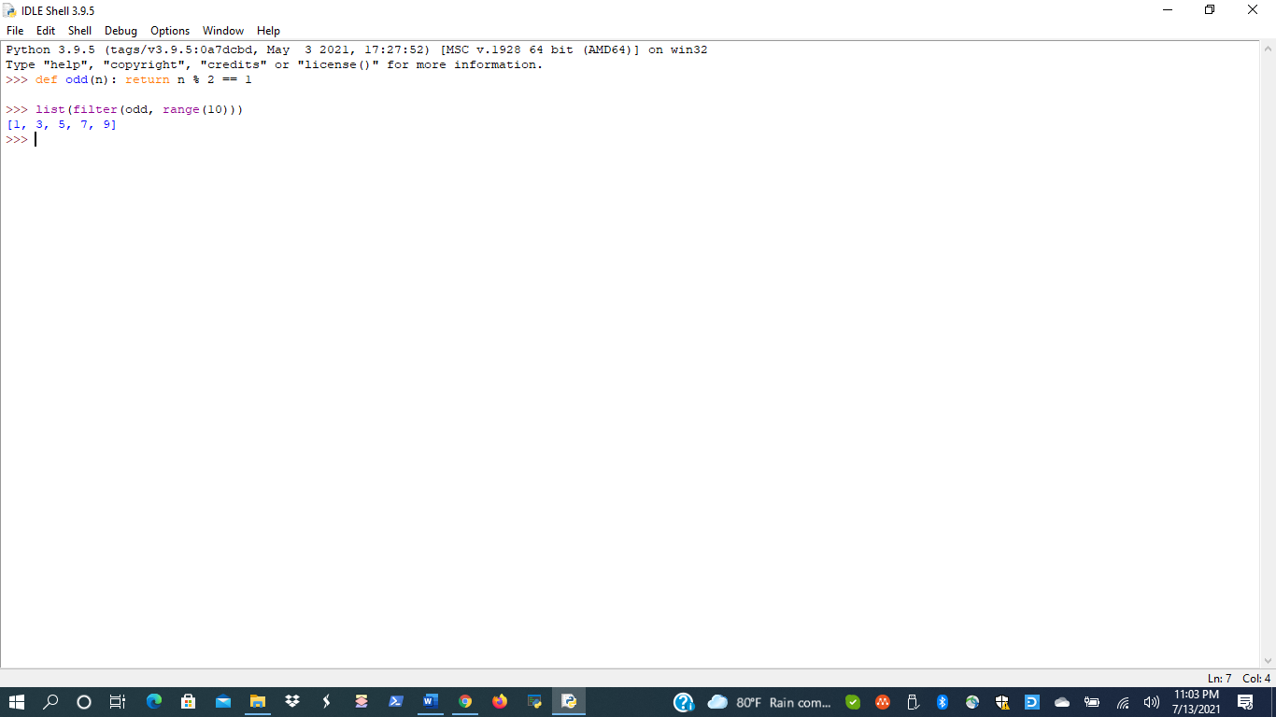

Pg. 198

1.

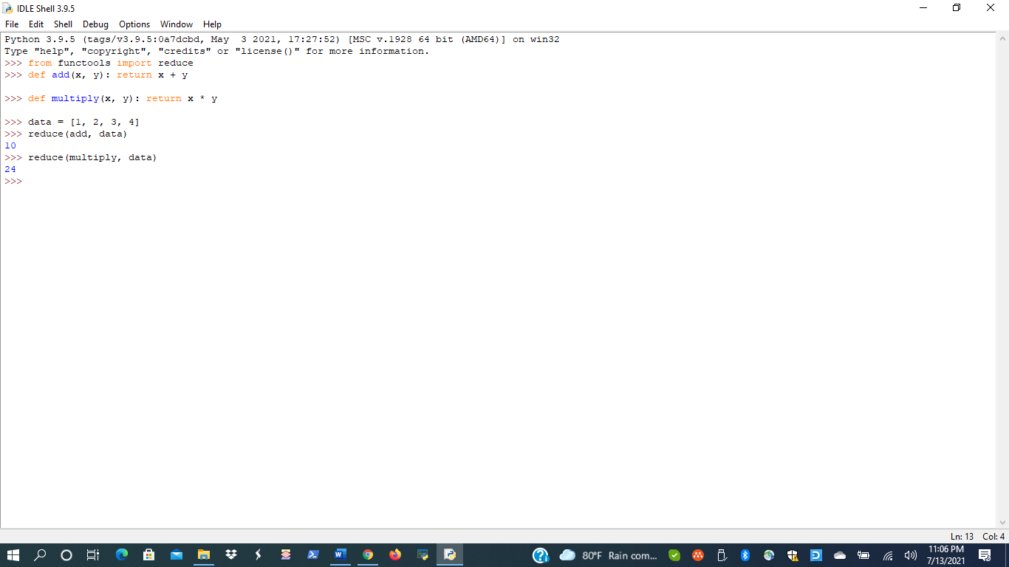

2.

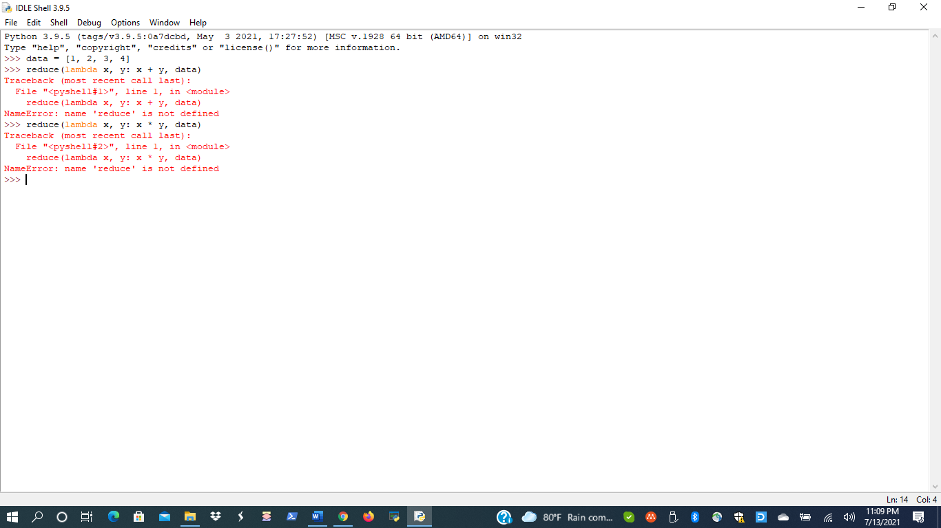

3.

